
LEGENDARY JOE WALSH IS BACK OUT ON THE ROAD TODAY WITH TOUR DATES THROUGHOUT THE SPRING AND SUMMER INCLUDING 23 WITH TOM PETTY AND THE HEARTBREAKERS ON THEIR 40TH ANNIVERSARY TOUR

JOE WILL ALSO HEADLINE A SHOW AT NEWLY RENOVATED GRACELAND LEADING LATEST RUNAWAY TOURS EXPERIENCE

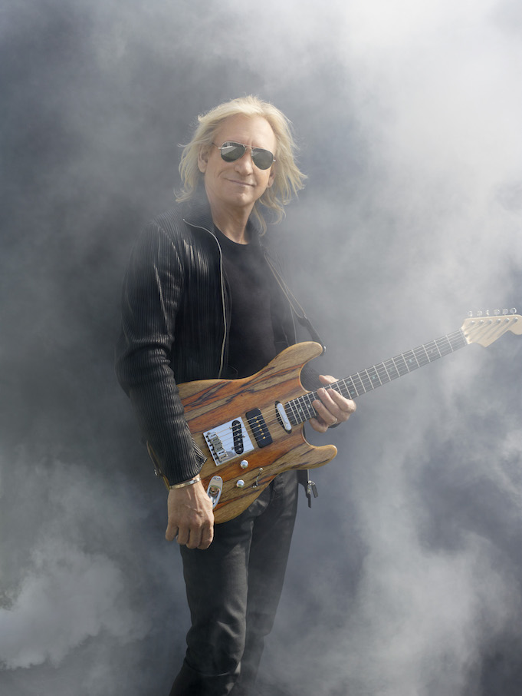

Watch Video

Thursday April 20, Oklahoma City, OK -- Joe Walsh is back out on the road today, including 23 dates as a very special guest on the Tom Petty and the Heartbreakers for their 40th Anniversary Tour. Joe will make a stop for a unique Storyteller like show at the newly renovated Graceland for their Runaway Tours Experience and fan weekend May 6-8. In July, Joe will join The Eagles Live and Fleetwood Mac at two of the most anticipated festival events this summer - The Classic West and The Classic East concerts.

With a catalog of hit songs spanning over four decades, Joe will be performing hits from throughout his career including “Walk Away,” “Funk 49” “Rocky Mountain Way” “In The City” “Life’s Been Good” “Life In The Fast Lane” right through to 2012’s ANALOG MAN, and as always, some surprises.

Joe’s band includes longtime collaborator and bandmate Joe Vitale on drums & keyboard; Chad Cromwell also on drums; Tom Bukovac on guitar; Jimmy Wallace on B3Organ & Keyboards; Larry Young on Bass & vocals and on background vocals Lois Mahalia, Leslie Page, Windy Wagner and Rickey Washington.

Joe Walsh and Joe Vitale recently answered fans’ questions Live on Facebook from rehearsals. They plan to do a few more while out on the road so fans should keep checking his website and Facebook for details.

Joe Walsh Tour Dates:

April:
20 Chesapeake Energy Arena, Oklahoma City, OK*
*with Tom Petty and the Heartbreakers
22 American Airlines Center, Dallas, TX *
23 Verizon Wireless Arena, Little Rock, AR *
25 Bridgestone Arena, Nashville, TN *
27 Phillips Arena, Atlanta, GA *
29 Cynthia Woods Mitchell Pavilion Houston TX *
30 Winstar World Casino and Resort, Thackerville, OK

May:
5 Perfect Vodka Ampitheatre, West Palm Beach, FL *
6 Amalie Arena, Tampa, FL *
7 Graceland All Shook Up at Graceland, Memphis, TN
8 FedEx Forum Memphis, TN*
10 State Farm Center, Champaign, IL *
12 Scottrade Center, St. Louis MO *
13 Klipsch Music Center, Noblesville IN *
19 Spotlight 29 Casino, Coachcella, CA
20 Doheny Blues Festival, Dana Point CA
29, 30 Red Rocks Ampitheatre, Morrison, CO *

June:
2 Sprint Center, Kansas, MO *
3 Xcel Energy Center, St Paul, MN *
5 Wells Fargo Arena, Des Moines, IA *
7 Schottenstein Center, Columbus OH *
9 PPG Paints Arena, Pittsburgh, PA *
10 Quicken Loans Arena, Cleveland, OH *
12 U.S. Bank Arena, Cincinnati, OH *
14 Xfinity Theatre, Hartford, CT *
16 Prudential Center, Newark, NJ *

July:
15 Dodger Stadium, Eagles Live @ The Classic West Los Angeles, CA
29 Citi Field, Eagles Live @ The Classic, East Queens, NY

For more information including links to get tickets go to:

JoeWalsh.com

Media Contact:
Elizabeth Freund Elizabeth@Beautifuldaymedia.com

About Joe Walsh:

Best known for his powerful guitar licks, multi-GRAMMY award winning singer, songwriter and producer Joe Walsh has entertained the masses and captivated his peers for more than four decades with such classics as “Funk #49,” “Walk Away,” “Life’s Been Good,” “Rocky Mountain Way,” “Life in the Fast Lane” and “Ordinary Average Guy.” In 1969 Walsh found success with The James Gang, followed by a stint with Barnstorm, a trio he founded. In 1973 Joe released his first solo album, which proved him a legitimate solo act with a limitless career on the horizon. By 1975 he joined The Eagles, bringing a harder rock sound to the group with the acclaimed and over 50 million selling hit Hotel California, The Long Run and Eagles Live. In 1994, after a 14-year hiatus and several solo albums, The Eagles released Hell Freezes Over, which reached #1 on the Billboard charts and sparked one of the most successful tours in music history. The Eagles were inducted into the Rock and Roll Hall of Fame in 1998, the first year they were nominated. In 2001 Walsh received an Honorary Doctorate from Kent State University and in 2012 the Berklee School of Music gave each of the Eagles Honorary Doctors of Music degrees. Walsh performed at the 2012 Grammy’s with Paul McCartney, Bruce Springsteen and Dave Grohl and at the 2012 MusiCares event honoring Paul McCartney. That June Walsh released Analog Man, his first solo album in 20 years, performing solo shows around the world to support it throughout that year. In 2013 the award winning The History of The Eagles showcased at Sundance, the two part authorized documentary, and in February it aired on Showtime. In conjunction with the April release onto DVD the Eagles began their extensive The History of The Eagles World Tour. On February 9, 2014 Walsh was featured in several songs on the CBS Special The Night That Changed America: A Grammy Salute to The Beatles. In 2014 Walsh played select solo shows as well as with the Eagles on The History of The Eagles World Tour, which continued through July of 2015. In Fall 2015 Joe launched his solo Walsh Toor 2015, and on October 4, 2015 Joe performed at the UNITE to Face Addiction rally in Washington DC, headlining with friends including Steven Tyler, Sheryl Crow and Jason Isbell. 2016 saw Walsh on the road, including a co-headline arena tour with Bad Company as well as solo Walsh Toor dates. In August 2016 “Citizen Soldier,” was released - a documentary about an Oklahoma National Guard deployed to Afghanistan - to which Joe wrote original music, and marked the launch of a charity he co-founded, VETS AID. Recently Walsh performed with Vince Gill, James Taylor, Chris Stapleton and Kacey Musgraves for All For The Hall. October saw Walsh as Grand Marshall for the NASCAR “Citizen Soldier 400” race at Dover Downs. On December 4th Walsh become a Kennedy Center Honor recipient as a member of the Eagles, which was presented by Ringo Starr. On December 8th MoPop gave Walsh “The Founders Award”, also presented by Ringo Starr and Paul Allen. The event included a tribute concert celebrating Walsh’s musical legacy by Dave Grohl and Taylor Hawkins, Paul Rodgers, Todd Rundgren, Robert Randolph and Kenny Wayne Shepherd. January 2017 saw Walsh perform a 6 show residency series at the House of Blues in Las Vegas.

